How well did I learn with and from others ?

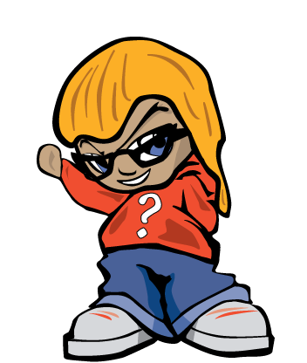
I took on a new role in my group today

I helped to pull together the information that we needed

I sorted out the order we needed to do things in

III suggested an improvement to someone else’s idea
I helped a team mate today by . . . . .
I changed my mind because my group suggested . . . . .
I …

I thought about how well we worked as a group

I showed respect to my team mates by . . . .
Learning about Collaborating

