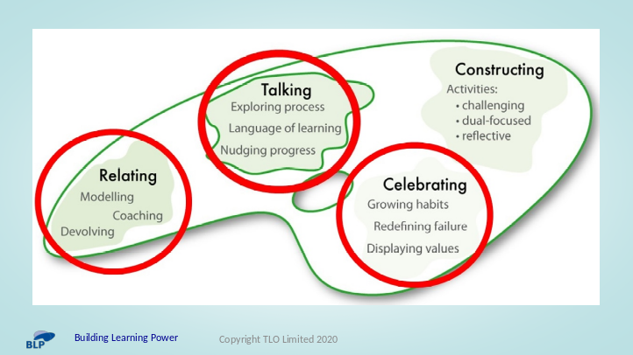

- Teachers met the Teachers’ Palette in Unit 1.

- In Unit 2 the focus is on 3 of the 4 aspects – Relating, Talking and Celebrating. [Teachers will spend around 3 months on Unit 2.]

- These 3 aspects are developed further and explained in Unit 2, Sections 2A, 2B and 2C. [Expect to spend about a couple of hours reading through sections 2A/B/C.]

- Section 2D lies at the heart of Unit 2. It links together:
- the learning profiles you have created for your class in Unit 1;
- the 4 foundational learning behaviours (Perseverance, Questioning, Collaboration, Revising);
- and these 3 aspects of classroom culture (Relating, Talking and Celebrating).

- Section 3D enables you to select from a range of practical teaching ideas. based on your analysis of your students’ progress in learning habits, that will help you to make your classroom culture increasingly learning-friendly. [Expect to spend most of the 3 months trialling ideas from section 2D.]



- Teachers may well have already seen this 3 minute YouTube clip in Unit 1 (Section 1A1), but it is worth revisiting as a reminder of what we are trying to achieve in terms of shifts in classroom culture.

- As they watch it, challenge them to identify a couple of things they might wish to trial in their own classroom.
- What excites them?
- What worries them?
- What would they like to have a go at, but need support to do so?

- [Remind them that the ideas they might need will be in Section 2D of Unit 2.]

- [Reminder – The 4th aspect of classroom culture, Constructing Learning, will be dealt with separately in Unit 3.]

- Access the clip via Unit 1, Section 1A1, or from the image to the right, or find the clip at:
- https://www.youtube.com/watch?v=fOqaKv-vvLk&pp=ygUXYnVpbGRpbmcgbGVhcm5pbmcgcG93ZXI%3D

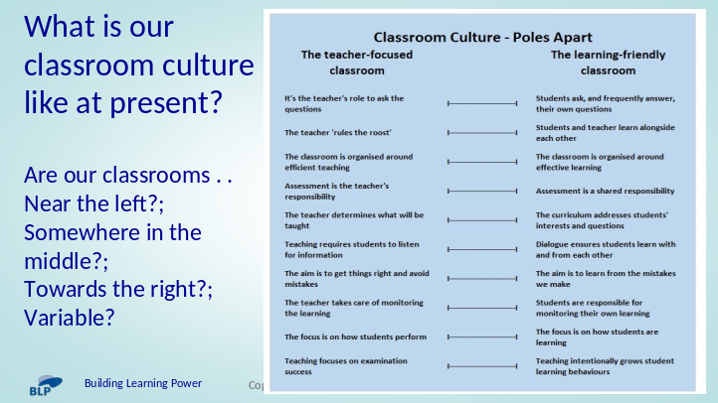

- A short team-based discussion – guestimate where our classroom culture is currently in relation to each of these 10 aspects of the teacher-focused classroom and the learning-friendly classroom.

- Where are our classrooms now?
- Near the left?;
Somewhere in the middle?;
Towards the right?;
- Variable?

- Use the discussion to get teachers thinking about their current classroom culture and how it might be different as classrooms become increasingly learning-friendly.

- Which aspects are already showing promise?
- Which ones do they think might be more tricky?
- Which ones might make the greatest difference to their students?

- [A full page view of this diagram is included in the handout for team members.]

