Slide 1

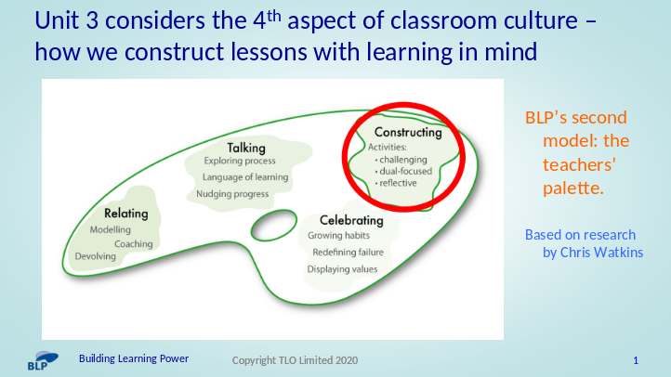

Unit 3 has a focus on the 4th aspect of classroom culture – how teachers create schemes of work, construct lessons and design activities that build positive learning habits.

It has a focus on how teachers:

- plan to weave learning behaviours and curriculum content together
- incorporate routines for thinking and learning
- design activities that promote perseverance, curiosity, collaboration, monitoring
- build in opportunities for reflection on learning

Like Unit 2, there are 4 sections that will take around 3 months to work through . .

Sections 3a, 3b and 3c explore issues around planning lessons with learning in mind. Expect to spend around a month reading about and reflecting on these 3 sections, after which we will meet to discuss them.

Section 3d is a treasure trove of teaching ideas that can be built in to lesson planning. Leave exploring section 3D for months 2 and 3.

Let’s take a quick look at these 4 sections . . . .

Slide 2

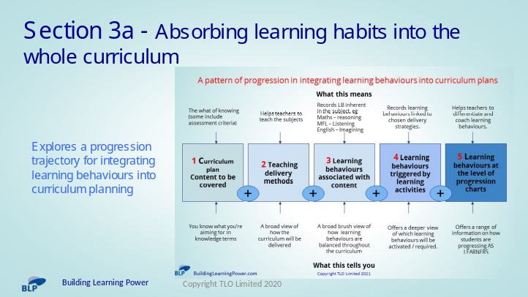

Considers 5 ‘levels’ of planning:

- 1. Content only planning – little more than a list of what will be covered and when

- 2. Content plus delivery methods – what will be covered, when and how

- 3. Content, delivery and learning behaviours – a step change, identifying and planning for the broad brush learning behaviours necessary to access the curriculum content

- 4. Content, delivery, learning and activities – a recognition that the planned activities also activate learning behaviours in addition to the ones necessary for content acquisition

- 5. Content, delivery, learning and activities – building fine grain learning behaviours drawn from progression trajectories into curriculum planning

Section 3a may lead to long-term changes in how we plan learning

First reaction – which of the 5 boxes best describes our curriculum planning ?

Slide 3

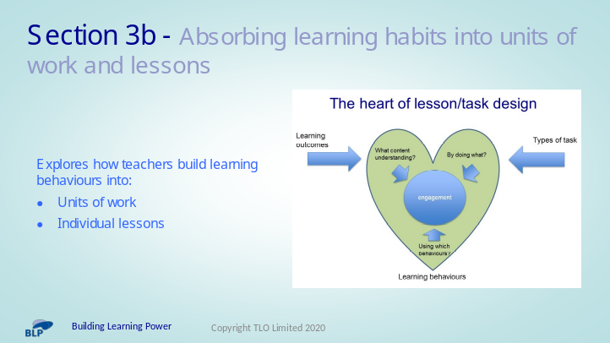

- Builds on Section 3a

- It explores linking content, learning behaviours and tasks/activities

- Considers the issues around building learning behaviours into medium term planning and individual lesson planning.

Slide 4

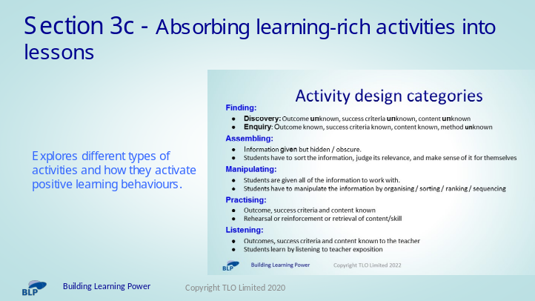

- Section 3C identifies 5 activity design categories and offers examples of each

- It invites us to consider the types of activities that we currently build into lessons and how we might broaden our activity repertoire

Slide 5

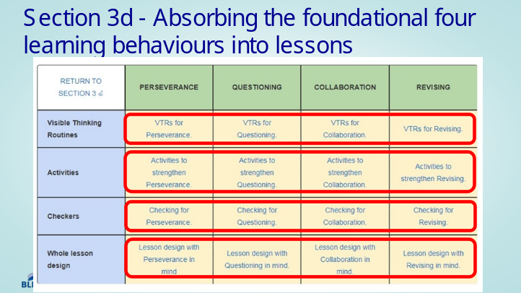

Is a treasure trove of teaching ideas to explore and build into lessons . .

For each of the 4 foundation learning behaviours, you are offered . .

6 or so Visible Thinking Routines

10 activities to build into lessons

10 ways of Monitoring the learning behaviours

a fully planned lesson for each learning behaviour to illustrate how you might design lessons with learning in mind.

