Unit 3 | 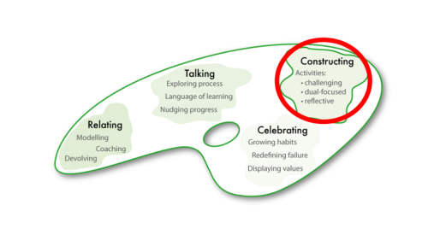 | ___________________________________  ___________________________________  ___________________________________  ___________________________________  ___________________________________  ___________________________________  ___________________________________
Section 3A | 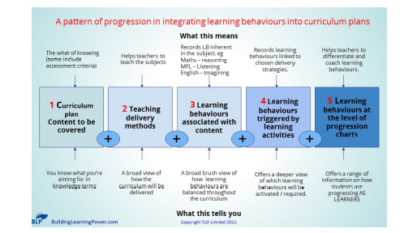 | ___________________________________  ___________________________________  ___________________________________  ___________________________________  ___________________________________  ___________________________________  ___________________________________
Section 3B | 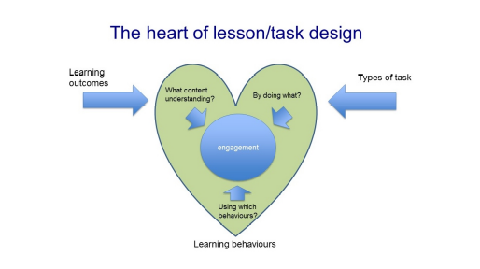 | ___________________________________  ___________________________________  ___________________________________  ___________________________________  ___________________________________  ___________________________________  ___________________________________
Section 3C | 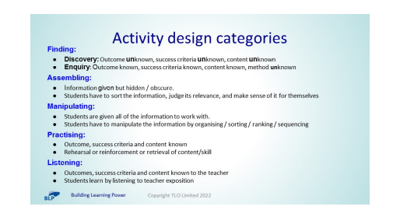 | ___________________________________  ___________________________________  ___________________________________  ___________________________________  ___________________________________  ___________________________________  ___________________________________
Section 3D |               

