Slide 1

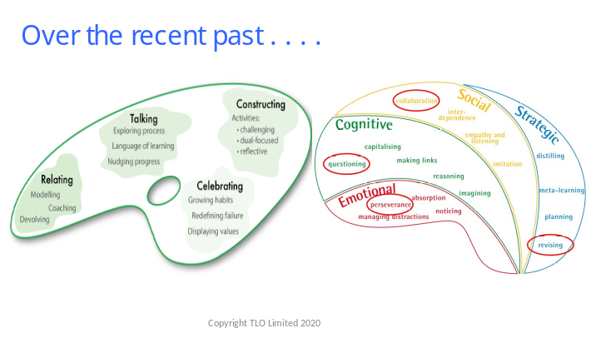

- Units 1, 2 and 3 have largely concerned themselves with exploring the 4 aspects of classroom culture (Relating, Talking, Celebrating and Constructing) through the lens of 4 key learning behaviours (Perseverance, Questioning, Collaboration, and Revising).

- It is now time to begin to explore the other 8 learning behaviours that were considered in Learning Profiles, but have taken a back seat to the big 4 over the past few months.

Slide 2

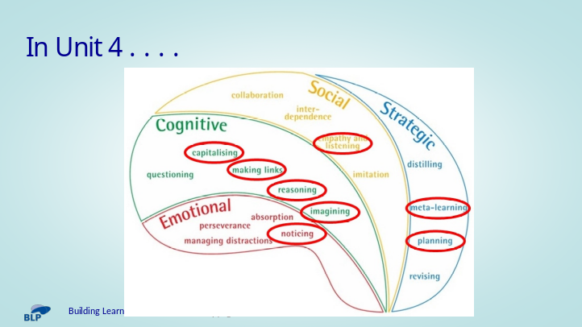

- Unit 4 offers an introduction to the other 8 learning behaviours that were considered in Learning Profiles – Noticing, Making Links, Reasoning, Imagining, Capitalising, Listening, Planning and Meta Learning.

- The 8 sections are ‘Toes in the Water’ sections – brief introductions to each of the 8, sufficient to get you going, but insufficient to dive in deeply (the deep dive is what Phase 2 is all about).

- There is no intention that you tackle all 8 of these behaviours over the next 2 months – if you manage to explore a couple of them, that would be great.

- The aim is to begin to ‘Broaden the Range’ of behaviours in your classroom in advance of moving on to a deeper exploration of these behaviours in Phase 2 of the programme.

Slide 3

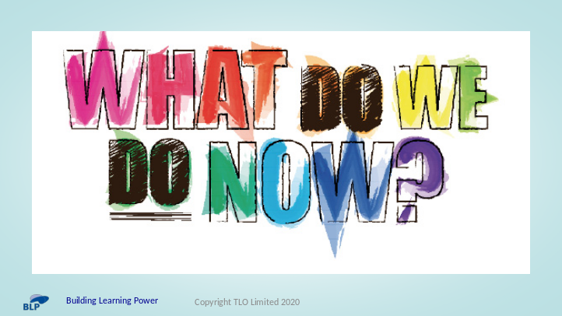

- So – how do we decide which of the 8 to focus on . . . .

- There are a number of possibilities . .
- Look back at your students’ learning profiles from Unit 1 and decide – maybe there is an obvious weakness that you would like to address?
- Focus on behaviours that interest you / fit well with your upcoming curriculum content
- We could share them out so that all of them get explored in at least one classroom
- We could decide together and all focus on the same ones
- We could all agree on one that we will all do, and leave the other as a free choice . . . .

- Initiate a discussion to explore how teachers wish to proceed
- Intend to close the discussion having agreed a course of action that all are happy with

