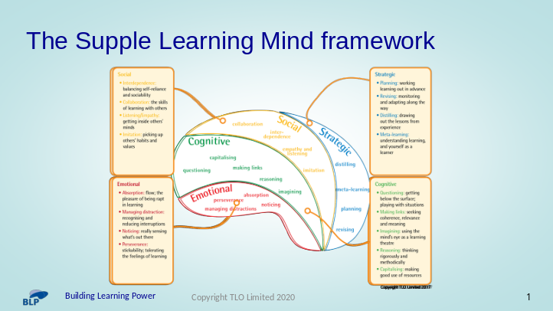

The Emotional aspects of learning:
- Perseverance - relishing a challenge; not afraid of finding things hard; persisting in the face of difficulties
- Managing Distractions – minimising external (and internal) distractions
- Absorption – maintaining focus for extended periods
- Noticing – identifying significant details.

- The Cognitive aspects of learning:
- Questioning - becoming curious about possibilities, asking questions to get to the bottom of things
- Making Links - seeing how things fit together, sensing patterns
- Reasoning – being logical and systematic
- Imagining - using imagination to good effect, being creative
- Capitalising - making use of a wide range of learning resources and strategies

The Social aspects of learning:
- Collaboration – learning with and from others
- Listening and Empathy - listening to what others say, showing understanding, putting themselves in others’ shoes
- Interdependence – balancing sociability and self-reliance, knowing when to learn alone or with others
- Imitation – noticing, absorbing and using the way other people do things

The Strategic aspects of learning:
- Planning - sorting out what needs to be done; thinking ahead of taking action
- Revising - taking stock to make sure things are on track; changing tack if necessary [Note – this is NOT about ‘Revising for a Test’, it is about openness to change.]
- Distilling - pulling out key points from experience
- Meta Learning – reflecting on learning, thinking about and talking about learning.

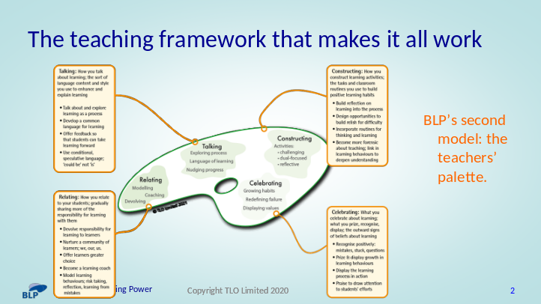

This framework describes 4 aspects of classroom culture.

Relating – How you relate to your learners, gradually sharing more responsibility with them:
- Devolving responsibility – shifting the emphasis towards learners taking increasing responsibility for their own development. It involves a shift towards students asking more of the questions, monitoring their own learning, doing more of the work, making more choices, pursuing their own lines of enquiry.
- Coaching – moving away from 'telling' whenever possible. It is one of the hardest of balancing acts: knowing when you can coach and when you have to tell requires the teacher to have a deep understanding of both the subject matter and the learner.
- Modelling – the ways in which we show that we, too, are learners. It indicates a shift away from teachers being 'all-knowing subject specialists' to displaying uncertainty, to sharing their own learning stories, to learning 'aloud', to learning alongside students.

Talking – How you talk about learning, the ways in which you explain the learning process:
- Creating a language for learning - helping learners to understand and use a language of sufficient precision and subtlety that enables them to describe, discuss and understand the learning process.
- Exploring learning as a process - the ways in which you enable learners to explore and reflect on the process of learning. It's a shift away from talking about the 'what' of learning and broadens classroom discourse to include conversations about the process of learning, the 'how' of learning.
- Nudging learning forward - offering feedback, both written and oral, to help learners to improve as learners. Nudging the learning process broadens feedback to include the learning behaviours employed as well as content.

Constructing – How you construct learning to build positive learning behaviours:
- Lessons with a dual focus - lessons are designed intentionally to deliver content and to exercise learning behaviours, and students are made aware of both. The learning behaviours drive the content acquisition, the content is the exercise regime for the learning behaviours, each enhancing the other;
- Lessons with rich and challenging activities - increasingly open-ended activities are designed to engage, to stretch and to challenge content understanding and learning behaviours.
- Lessons with in-built reflection - reflection on content and reflection on learning behaviours is routinely built into lessons.

Celebrating – What you celebrate, recognise, praise and display:
- Displaying values - the process of learning (as opposed to the finished outcomes of learning) are on display. What we choose to display tells students a lot about what we truly believe. In such ways are the underlying values of the classroom revealed to learners.
- Re-defining failure - turning the lens around: mistakes become learning opportunities; difficulty is when learning happens; struggle is to be expected; asking questions shows curiosity, not a lack of intelligence; effort not just talent is what leads to success. It is about ensuring that hard won gains over the difficult are preferable to effortless success over the easy.
- Growing Learning habits - finding ways to notice, track, record and celebrate learning behaviour growth. In the same way that attainment is routinely tracked, recorded and celebrated, so is learning itself.

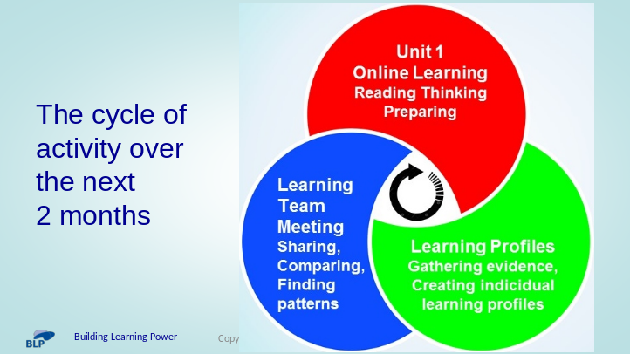

Online learning (Reading Unit 1, sections 1A/B/C/D). Give yourself around a month to work through these 4 sections.
- Section 1A describes the 2 key models of learning power – the supple learning mind and the teachers’ palette
- Section 1B is a short read to give confidence that the approach is valid with a long history of research and development
- Section 1C helps you become aware of how learning behaviours grow and develop. It’s an eye-opening read about the complex nature of twelve learning habits.
- Section 1D is about taking what you have learned about the learning habits and thinking about how these ideas apply to yourself and a couple of your students.

Learning Profiles (Unit 1, section 1E). Create learning profiles for all of the children in your class. Summarise what you have discovered about your learners.

- Section 1E sets you up with intriguing, new and valuable information about your students, to help you discover different aspects of your students as learners.
- This is the key part in Unit 1 – it is designed to give teachers an insight into how their students are as learners
- It enables teaches to begin to explore patterns, similarities and differences.
- At this stage, it should raise many intriguing questions relating to how learning behaviours impact of attainment.

Team Meeting (at the end of the 2 months). Meet together to share ideas, seek similarities and differences.
- This is the first team meeting in Playing the Learning Power Game.
- It looks back over Unit 1, and in particular encourages teachers to share their perceptions of their students’ learning behaviours as captured in the learning profiles.
- These profiles frame the how teachers will tackle Unit 2.

[Note that this cycle of activity for Unit 1 is unique.
From Unit 2 onwards, the programme employs an approximately monthly cycle of Online Reading / Team Meeting / Classroom Experiments.]

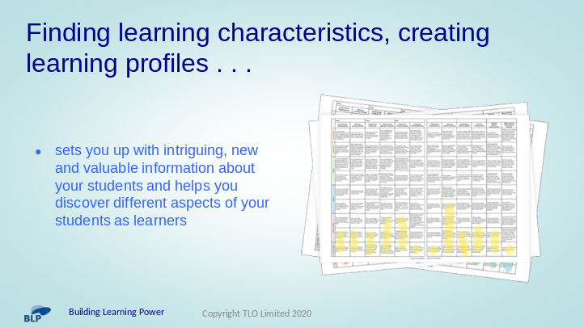

More about Section 1E - ‘Finding learning characteristics’ - invites teachers to turn their attention to their own class and to build learning profiles for each of them individually.

- To give teachers an idea of what thy will be aiming to achieve, take some of the profiles you have created for you own class with you.
- Be ready to discuss:
- the patterns you are spotting;
- the questions that you are asking yourself;
- how long it took you to create the profiles
- how you went about it
- What you found tricky / easy

